Visual Query
Planner
Three cognitive tasks:
- Identifying tasks
The planner helps us identify what needs to be done by using visual patterns to group items. For example, a briefcase icon indicates work-related tasks, while a food icon is used for grocery items.
- Prioritizing tasks
Color-coding can be used to highlight important or urgent tasks, making it easier to decide what to focus on first.
- Planning deadlines and events
Checkboxes help reduce memory load and make it easier to track progress toward deadlines or events.
The places to be improved:
- Fonts are sometimes too small or use unfamiliar styles, which makes them harder to read.
- Color saturation is weak, reducing visual clarity.
- All category boxes are the same size, but some categories are more important and should be visually larger to reflect priority.
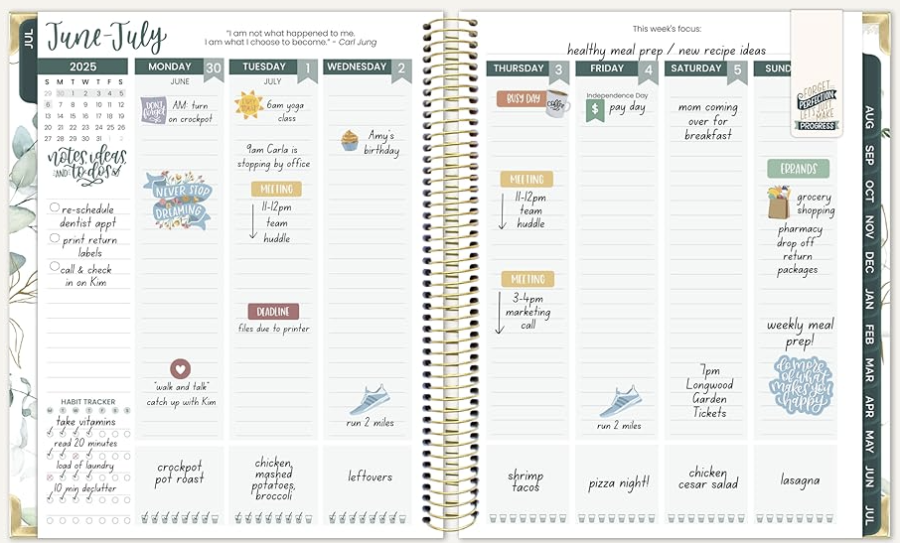
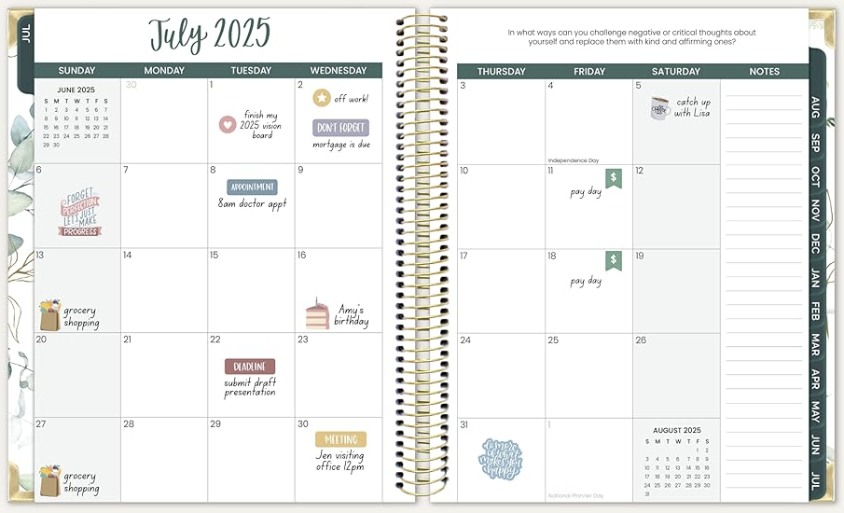
Amazon.com : bloom daily planners 2025-2026 Hardcover Academic Year Goal & Vision Planner (July 2025 - July 2026) - Monthly & Weekly Calendar Agenda Organizer - 7.5" x 9" - Spread Kindness Like Wildflowers : Office Products

